Buzzing Buzzer Using ESP32 with Wi-Fi

Description:
The Buzzing Buzzer Using ESP32 with Wi-Fi project demonstrates how a buzzer can be controlled wirelessly using an ESP32 microcontroller.
In this project, the ESP32 connects to a Wi-Fi network and hosts a simple web server.
Using a web browser, the user can remotely turn the buzzer ON or OFF.
This project introduces basic IoT concepts such as wireless communication, web-based control, and GPIO interfacing.
Block Diagram:
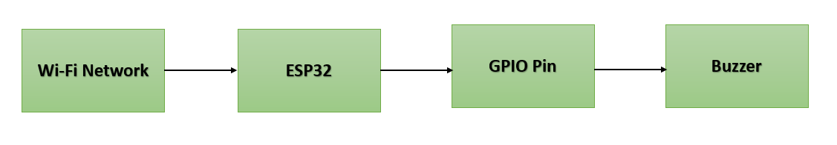

Pinout / Circuit Connection:
- ESP32 GPIO 4 → Buzzer (+)
- Buzzer (–) → GND
- Power Supply → 5V (USB cable to ESP32)

Components Required:
- ESP32 Development Board
- 1 × Active Buzzer
- Jumper Wires
- Breadboard
- Wi-Fi Network

Working Principle:
The ESP32 has a built-in Wi-Fi module that allows it to connect to a wireless network.
After connecting to Wi-Fi, the ESP32 runs a web server.
When a user accesses the ESP32 IP address through a browser, control commands are sent.
Based on the received command, the ESP32 sets the buzzer GPIO pin HIGH or LOW, causing the buzzer to turn ON or OFF.
Operation (Step-by-Step):
• Connect the buzzer to the ESP32 GPIO pin
• Upload the Wi-Fi buzzer control program to the ESP32
• Power ON the ESP32 using a USB cable
• Open the Serial Monitor to note the ESP32 IP address
• Enter the IP address in a web browser
• Press ON/OFF buttons to control the buzzer wirelessly
Arduino Code:
#include <WiFi.h>
#include <WebServer.h>

const char* ssid = "YOUR_WIFI_NAME";
const char* password = "YOUR_WIFI_PASSWORD";

WebServer server(80);
#define BUZZER_PIN 4

void handleRoot() {
String html = "<h2>ESP32 Buzzer Control</h2>";
html += "<a href=\"/on\"><button>BUZZER ON</button></a><br><br>";
html += "<a href=\"/off\"><button>BUZZER OFF</button></a>";
server.send(200, "text/html", html);
}

void handleOn() {
digitalWrite(BUZZER_PIN, HIGH);
server.send(200, "text/html", "Buzzer ON");
}

void handleOff() {
digitalWrite(BUZZER_PIN, LOW);
server.send(200, "text/html", "Buzzer OFF");
}

void setup() {
Serial.begin(115200);
pinMode(BUZZER_PIN, OUTPUT);

WiFi.begin(ssid, password);
while (WiFi.status() != WL_CONNECTED) {
delay(500);
Serial.print(".");
}

Serial.println("\nWiFi Connected");
Serial.println(WiFi.localIP());

server.on("/", handleRoot);
server.on("/on", handleOn);
server.on("/off", handleOff);
server.begin();
}

void loop() {
server.handleClient();
}

Conclusion: (Predefined/self-written)
The Buzzing Buzzer Using ESP32 with Wi-Fi project demonstrates wireless control of an audio output device using IoT technology.
It helps learners understand ESP32 Wi-Fi capabilities, web server operation, and digital output control.
This project can be extended to alarm systems, smart doorbells, and notification systems.
For Your References:
[1] Espressif Systems, ESP32 Series Datasheet, Espressif Systems Inc., 2016.
[2] N. Kolban, Kolban’s Book on ESP32, 1st ed., USA, 2017.
[3] Arduino, “WiFi Library for ESP32,” Arduino.cc. [Online]. Available: https://www.arduino.cc/en/Reference/WiFi. [Accessed: Jun. 10, 2018].
[4] Arduino, “Digital Output Control,” Arduino.cc. [Online]. Available: https://www.arduino.cc/reference/en/language/functions/digital-io/digitalwrite/. [Accessed: May 12, 2017].

